Andrew Alferman
MTH 552
Homework #4
Due Wed, Feb 15, 2017

1) The attached MATLAB code has been modified as directed. The code allows for either fixed stepsize or automatic stepsize to be selected, depending if the value assigned to “autostep” is true or false. The “method” variable represents the numerical method to be used; 'RK1' and 'ExplicitEuler' represent the Euler method, 'RK4' represents the RK method from problem 2 of Assignment 2, and 'HW2' represents the RK method from problem 2 of Assignment 2. The “steps” variable counts how often the function f is being evaluated.

A tolerance of 1x10⁻⁷ was selected because it yielded a visually correct plot of u₁ versus u₂ for all three methods evaluated. A tolerance value of 2x10⁻⁷ with the HW2 method yielded a plot that was noticeably distorted, while the Euler method and RK4 methods yielded acceptable plots at that tolerance value. The code output the figures below. The number of steps can be found on each graph. All three methods came up with comparable plots, however the RK4 method was much faster than the other two methods. Although the HW2 method used fewer steps than the Euler method (RK1), the computation time was similar due to the larger number of computations needed for each step.
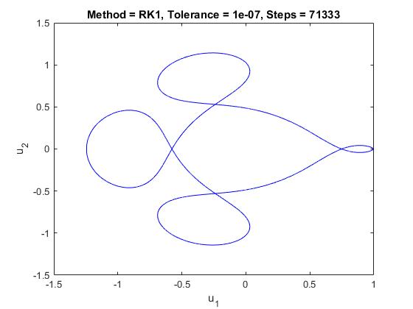
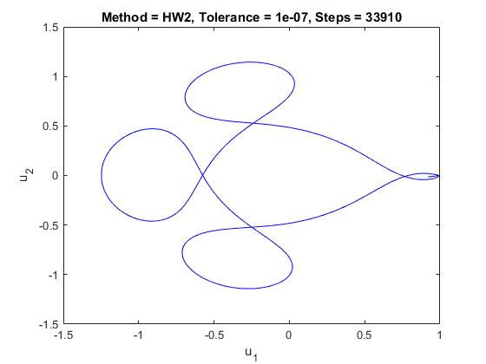
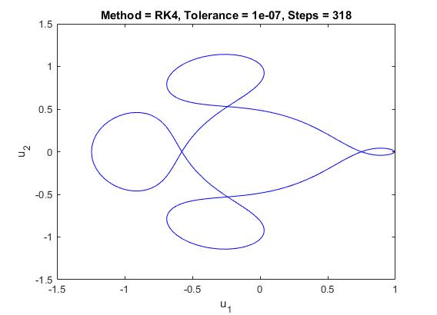
2)

